# CURRICULUM VITAE

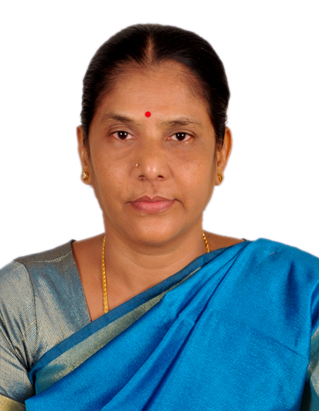

**Mrs. Saradha. S,**

**No 9, VGN Milano Square,**

**Kamarajar Street, East Tambaram,Chennai-59.**

**Mobile No: 94445 70958**

**E-mail ID: sarakottaiyan@gmail.com**

**DOB: 08.04.63**

**_____________________________________________________________________**

**VISION**

**“TO BE THE BEST VISIONARY, VIBRANT EDUCATIONIST IN THE FIELD OF EDUCATION BY EXECUTING THE UNDERTAKEN TASK WITH LOYALTY, COMMITMENT & PERSEVERANCE.”**

**Professional Profile**

**Qualification : M. A, B.Ed., M.Phil.**

**Specialization : English**

**Experience : 30yrs. (16 yrs Principal, 1yr - CEO - Pon**

**Vidhyashram Group of CBSE Schools,**

**13 yrs. PGT, English at SBOA)**

**Current Designation : Serving as a Principal for Shikshaa Public School, Chromepet from 2025 April to till date.**

**Current CTC : 1,00,000/- Per Month**

**Previous Experience : 2018 April - 2024 March 31,**

**Principal of SMK Vidhyashram & Junior**

**College, Kodungaiyur.**

**2015 -2018 March, Principal of Terapanth**

**Jain Vidhyalaya MHSS, Sowcarpet**

**: 2013 - 2015**

**Educational Advisor &**

**Principal for Shree Sankalpa**

**School, CBSE,Guduvancherry**

**: 2011 - 2013**

**Principal for**

**Satheesh Balaji MHSS.**

**: 2009-2010**

**Headmistress in The Govt.Aided School named A.G Jain HSS, Sowcarpet.**

**: Principal of SJT Surana**

**Jain Vidhyalaya, Sowcarpet from 2008 to**

**2009.**

**: 2006-08,**

**Headmistress for the Senior Secondary in The Velammal International School, Panchetti.**

**: Worked in London from 2005-06 with HSMP Visa, UK**

**: 1992-2005 (13 yrs.), PGT Senior English Teacher in SBOA MHSS Anna Nagar West Extn.**

**ACCOMPLISHMENTS: Implemented AI, Coding & Robotics**

**at the Primary classes itself.**

**Made the pupils complete the certificate course in Computer Science**

**in Grade eight by registering the school in the renowned university.**

**Educational Consultant, Academic**

**Adviser, English Language Skills’**

**Trainer, Event Manager & Educational Website Designer.**

**Served as a Consultant to set up New**

**Global School at Jamin Korattur with**

**IGCSE, IB & CBSE Curriculum,**

**Sree Sankalpa School, CBSE at**

**Guduvancherry**

**Designed the website of the schools**

**Where ever I served as a School Head**

* **Trained teaching staff and pupils to enhance their LSRW**
* **Served as the Head & the Trainer for SMK VIDHYASHRAM Nursery & Primary teacher Training Institute**
* **Conducted Orientation Programmes, CCE (CBSE&MATRIC) trained to master Soft skills, rendered effective periodical workshops and seminars to the teaching fraternity to enrich their professional skills**
* **Trained & motivated the staff and the students to take part and bag the accolades in all sorts of contests, sports & games at various levels**
* **Set up Multimedia English Language Lab**
* **Efficient Administrator, Committed Academician, Effective**

**Subject Expert, Conscious Counseller**

**& Dynamic Disciplinarian.**

* **Author & Editor of School Academic Year Planner, Dossier, Prospectus, Magazine, Souvenir, Advertisements & School Diary**
* **Choreographed for all the Cultural**

**Programmes, Managed the Thematic Relevant**

**Events Aesthetically & Effectively**

**NOTEWORTHY DEEDS :**

* **Toured to Singapore & Malaysia and visited the Educational Institutions over there.**
* **Introduced various CCA &ECA**
* **Trained the staff to teach through the Digital Training System & PPT**
* **Various staff committees were formulated**
* **Encouraged the staff and the students to enhance their communication skill**
* **Students & staff were motivated to showcase their potential**
* **In order to gain entry into the globally renowned institutions, Trinity College of London ASL Examination & Competitive Exams were introduced**
* **International Exchange Programmes (USA) for students were being conducted.**

**SPECIAL INTERESTS:**

**To master the latest technology, work for the Woman’s Empowerment, learn foreign languages & experimenting innovative ideas.**

**HOBBIES:**

**Viewing English Reality Shows, Listening to Music & Zen Stories, Reading Informative Books, Articles and Indian Epics.**

**REFERENCES:**

1. **Sri R.Vivekanantan,**

**Former President &Chairman of Sree Muthukumaraswamy Educational**

**Society.**

**Mobile No: 9382150802**

**2. Mr.Karthikeyan**

**Former Correspondent of Kalaimagal Matriculation & HSS**

**Mobile: 9841111026**

**Date: 22.09.25 Signature: S Saradha**